Lentil Lime Salad

* [Nutrition](http://www.beachbody.com/beachbodyblog/category/nutrition)

* [Recipes](http://www.beachbody.com/beachbodyblog/category/nutrition/recipes)

April 25, 2014

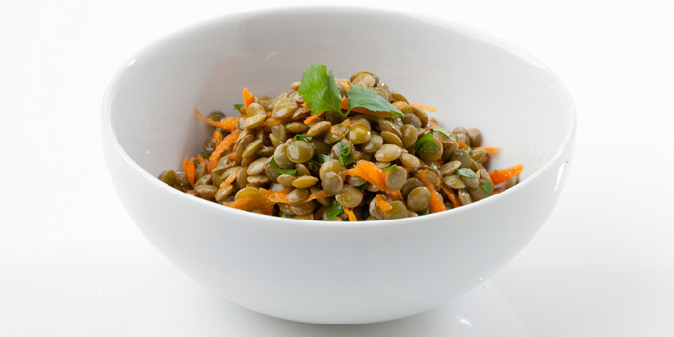

Lentils are filling because they are packed with protein and fiber. This delicious salad can be eaten as is, or served atop leafy greens.

**Total Time:** 2 hrs. 5 min.  
**Prep Time:** 5 min.  
**Cooking Time:** None  
**Yield:** 1 serving

1 cup cooked green lentils  
1 medium carrot, shredded  
¼ cup finely chopped fresh cilantro  
1½ tsp. sesame oil  
2 Tbsp. fresh lime juice  
Braggs Liquid Aminos  
Himalayan salt (to taste; optional)  
¼ tsp. ground cumin (to taste; optional)  
Ultimate Reset® herbal seasoning blend or fresh herbs like basil and oregano (to taste; optional)

1. Combine lentils, carrot, cilantro, oil, lime juice, Braggs Liquid Aminos, salt (if desired), cumin (if desired), and seasoning blend (if desired) to lentils; toss gently to blend.  
2. Let salad marinate, covered, in refrigerator for 2 hours before serving.

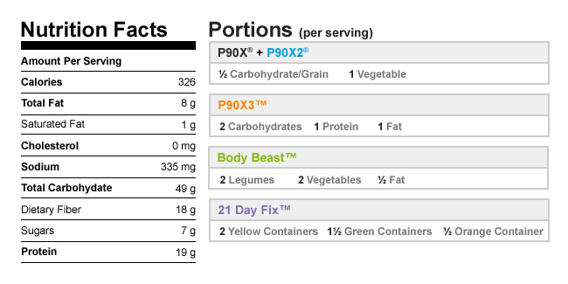

Authors

[Beachbody](http://www.beachbody.com/beachbodyblog/author/beachbody)

Tags[fiber](http://www.beachbody.com/beachbodyblog/tag/fiber), [high-protein](http://www.beachbody.com/beachbodyblog/tag/high-protein), [lentils](http://www.beachbody.com/beachbodyblog/tag/lentils),[recipes](http://www.beachbody.com/beachbodyblog/tag/recipe), [salad](http://www.beachbody.com/beachbodyblog/tag/salad), [vegan](http://www.beachbody.com/beachbodyblog/tag/vegan),[vegetarian](http://www.beachbody.com/beachbodyblog/tag/vegetarian)

RELATED POSTS